Pizza Party TEAM P Dan Smestad ITEC 2505_60 Mondays 12-3pm

Week 9 - Fun Project

Your team has a project to complete during class time.

Each team member will upload a document with screen shots of code and some sample runs.

Each team member will contribute ideas, syntax, energy, and perhaps a share of the typing.

Good time management is essential as time is limited.

If there is a presentation, each team member will take part in presenting the team's application.

Include the following: arrays and collection processing, input validation and exception handling, date processing and calculations, output formats, great user experience including some graphics and maybe animation, PLUS all the default requirements such as good GUI layout, tabbing, Enter and Esc keys, object/control naming, and comments!

We choose:

Pizza party calculator: include size, toppings, extras, prices, pizza purchase summary list.

I tried several loops to display two different orders but Order #1 , Order #2 all I could get working was to display Order #, but not the number. It doesn’t crash that I can tell.

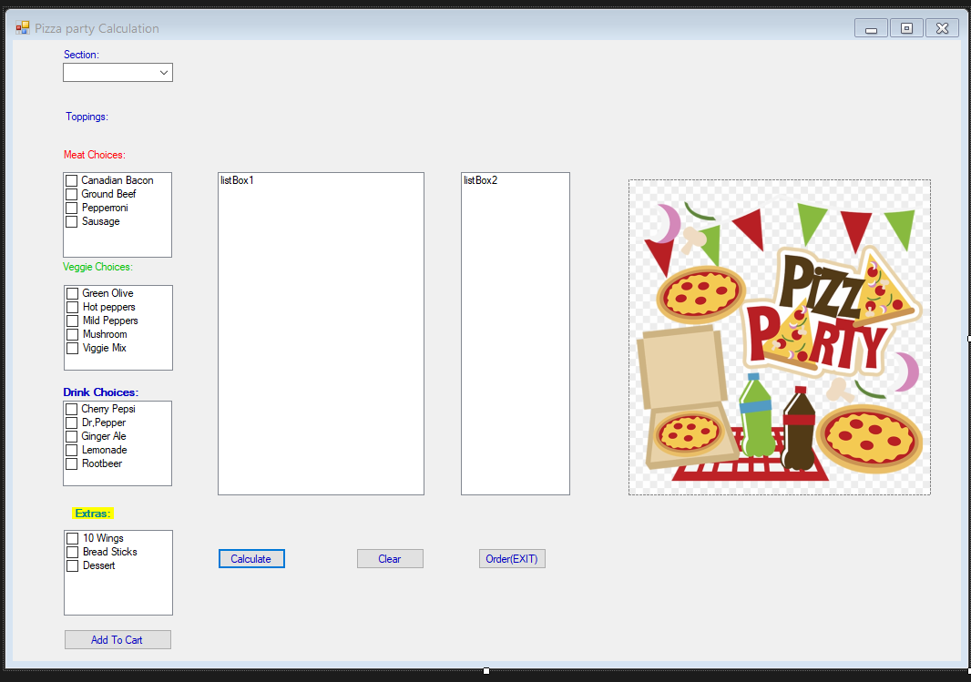

Code:

using System;

using System.Collections.Generic;

using System.ComponentModel;

using System.Data;

using System.Drawing;

using System.Linq;

using System.Text;

using System.Threading.Tasks;

using System.Windows.Forms;

namespace Pizza_party

{

public partial class Form1 : Form

{

public Form1()

{

InitializeComponent();

}

double price = 0.0; //declaring variable and their values, price will change as program runs.

double lPrice = 20.00; //declaring variable and their values, Large pizza.

double mPrice = 15.00; //declaring variable and their values, medium pizza.

double sPrice = 12.00; //declaring variable and their values, samall pizza.

double pPrice = 10.00; //declaring variable and their values, personal size pizza.

double dPrice = 2.00; //declaring variable and their values, price for drink.

double toppings = 3.00; //declaring variable and their values, topping meat, or veggies.

double bwdPrice = 5.00; //declaring variable and their values, bread, wings dessert price.

private void btnCalculate_Click(object sender, EventArgs e) //works will form to calculate .

{

if (IsValidData()) //method to check data validation.

{

string size = Convert.ToString(combosize.SelectedItem); //declaring size combobox user will seelction from drop down list on form

listBox1.Items.Add(size); //declaring size to add items to list box 1.

listBox2.Items.Add("Total:"); //adding Total for display in listbox2 for cost.

listBox2.Items.Add("------------"); //addd lines for seperation readability to the listbox totals.

if (combosize.SelectedIndex == 0) // chceks index 0 is checked, and completes if true, this is Large.

{

listBox1.Items.Add(lPrice.ToString("c")); //optput to listbox displaying the price

price = price + lPrice; //price for large size is added to price if selected.

}

else if (combosize.SelectedIndex == 1) // chceks index 0 is checked, and completes if true, this is Large.

{

price = price + mPrice; //price for medium size is added to price if selected.

listBox1.Items.Add(mPrice.ToString("c")); //optput to listbox displaying the price.

}

else if (combosize.SelectedIndex == 2) // chceks index 0 is checked, and completes if true, this is Large.

{

price = price + sPrice; //price for small size is added to price if selected.

listBox1.Items.Add(sPrice.ToString("c")); //optput to listbox displaying the price

}

else if (combosize.SelectedIndex == 3) // chceks index 0 is checked, and completes if true, this is Large.

{

price = price + pPrice; //price for personal size is added to price if selected.

listBox1.Items.Add(pPrice.ToString("c")); //optput to listbox displaying the price

}

listBox1.Items.Add("------------"); //addd lines for seperation readability to the listbox.

foreach (string meat in chkListMeats.CheckedItems)

{

price = price + toppings; //price for addional selected itmes is added to price.

listBox1.Items.Add(meat); //displays meats selected to listbox.

listBox1.Items.Add(toppings.ToString("c")); //output to listbox displaying,price total and adding topping cost.

listBox1.Items.Add("------------"); //addd lines for seperation readability to the listbox totals.

}

foreach (string veggie in chkListVeggies.CheckedItems)

{

price = price + toppings; //price for addional selected itmes are added to price.

listBox1.Items.Add(veggie); //displays veggie selected to listbox.

listBox1.Items.Add(toppings.ToString("c")); //output to listbox displaying,price total and adding topping cost.

listBox1.Items.Add("------------"); //addd lines for seperation readability to the listbox.

}

foreach (string drink in chkListDrinks.CheckedItems)

{

price = price + dPrice; //price for addional selected itmes are added to price.

listBox1.Items.Add(drink); //displays drinks selected to listbox.

listBox1.Items.Add(dPrice.ToString("c")); //output to listbox displaying,price total and adding drink cost.

listBox1.Items.Add("------------"); //addd lines for seperation readability to the listbox.

}

foreach (string extras in chkListExtras.CheckedItems)

{

price = price + bwdPrice; //price for addional selected itmes are added to price.

listBox1.Items.Add(extras); //displays extras selected to listbox.

listBox1.Items.Add(bwdPrice.ToString("c")); //output to listbox displaying,price total and adding extras cost.

listBox1.Items.Add("------------"); //addd lines for seperation readability to the listbox.

}

string tprice = price.ToString("c"); //output to listbox displaying the Total price

listBox2.Items.Add(tprice); //varible delared holding the total price from all check items.

}

}

private bool IsValidData() //code for data validation. We are checking box is checked

{

if (combosize.SelectedIndex == -1)

{

MessageBox.Show("Please select a pizza size.",

"Entry Error");

combosize.Focus();

return false;

}

return true;

}

private void btnClear_Click(object sender, EventArgs e)

{

listBox1.Items.Clear(); //clearing items from the list of selected pizza items

listBox2.Items.Clear(); // clearing the cost totals

combosize.SelectedIndex = -1; //clearing out the combobox

price = 0.0; //clearing the price value so we can recalculate the cost.

}

private void btnExit_Click(object sender, EventArgs e)

{

this.Close();

}

// accidental click not needed/or used

private void pictureBox1_Click(object sender, EventArgs e)//accidental click not needed/or used

{

}

// accidental click not needed/or used

//not used

private void btnAdd_Click(object sender, EventArgs e) //not used

{

//not used

}

}

}

Running program data validation:

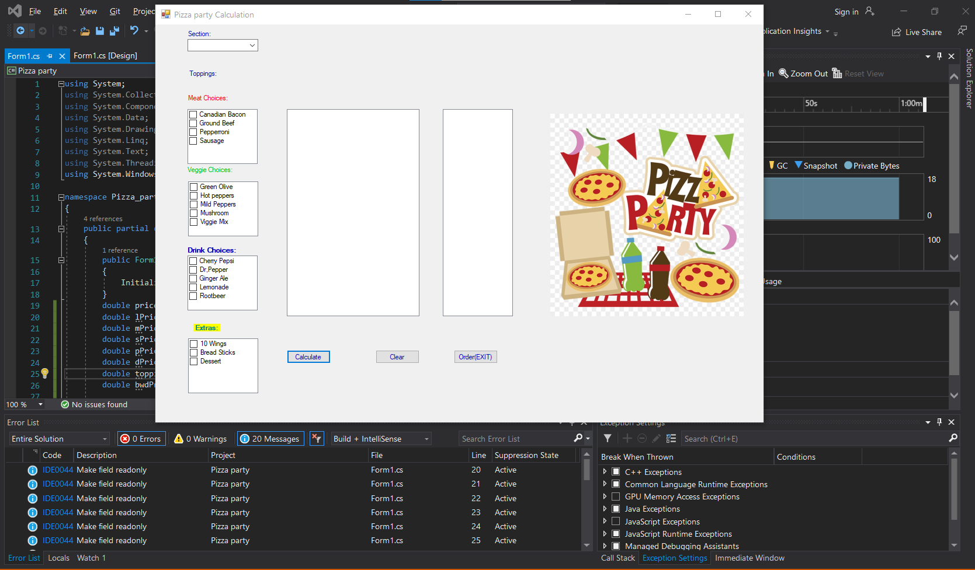

No pizza size selected from combo box

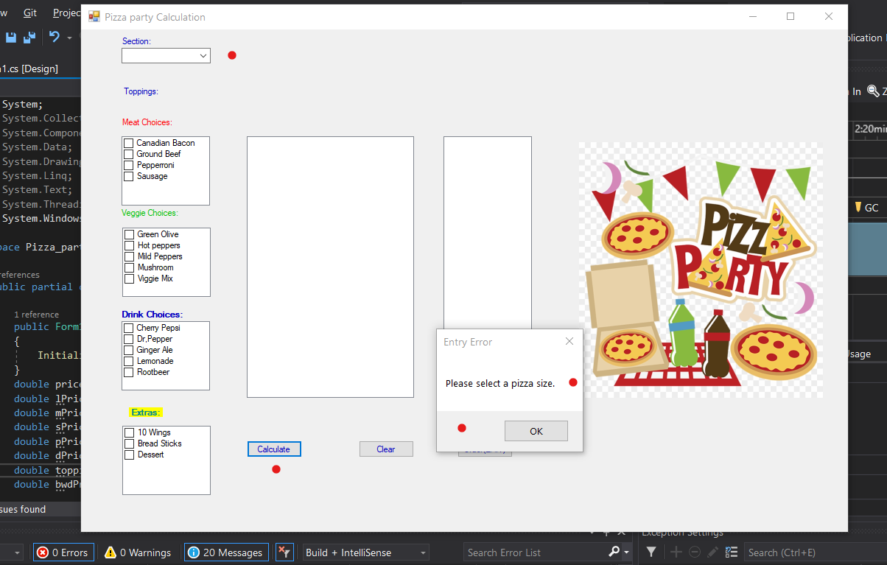

Ordering a pizza twice no other selection

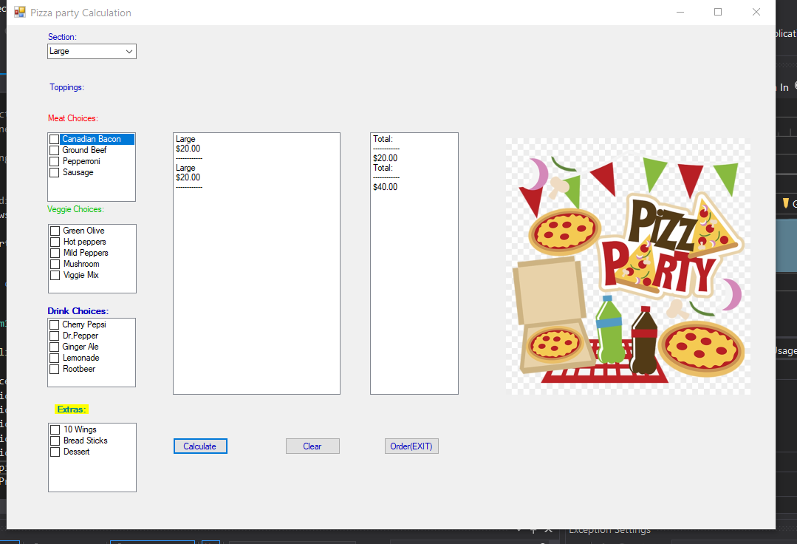

Selection with other items medium:

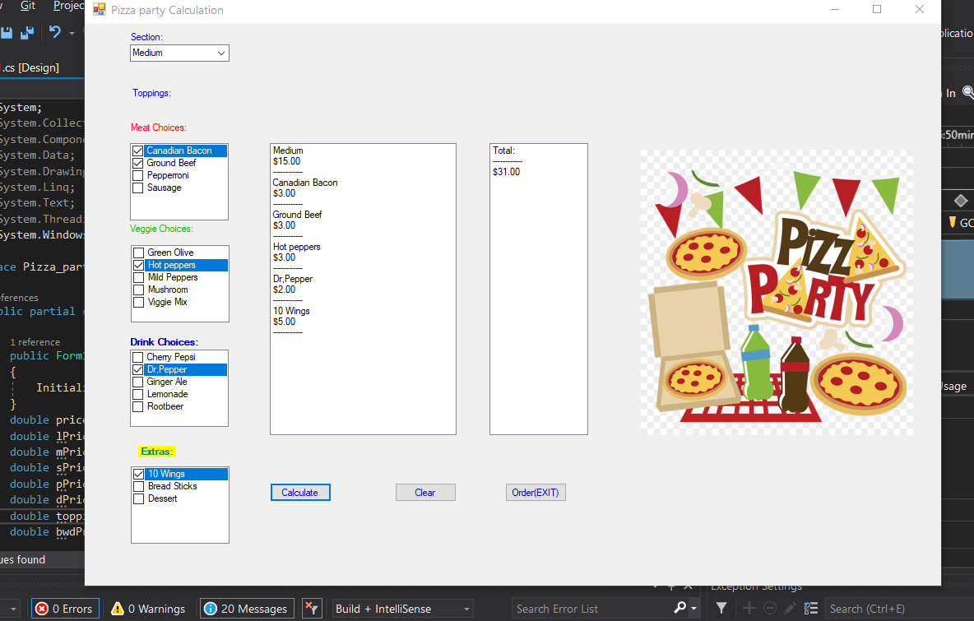

Clear:

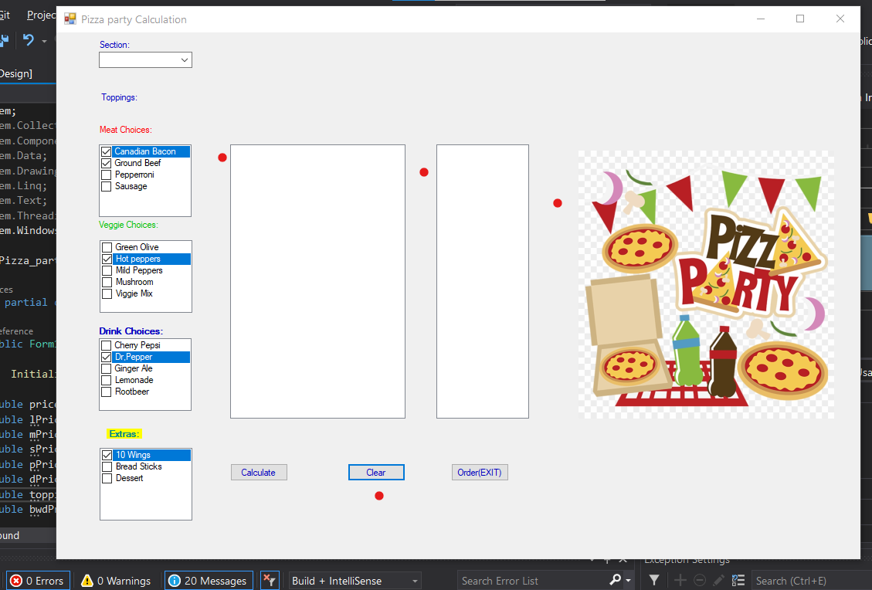

Small:

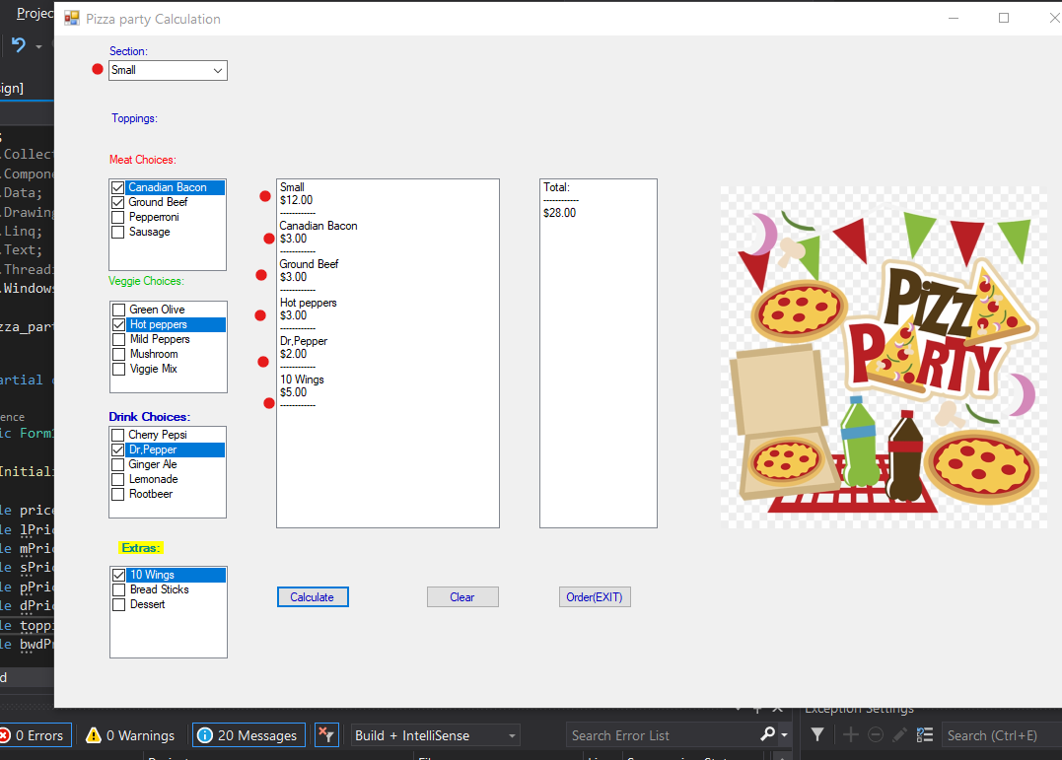

Personal size and ordering drinks for friends not sharing my pizza and a dessert also list box scroll shows up with so many items.

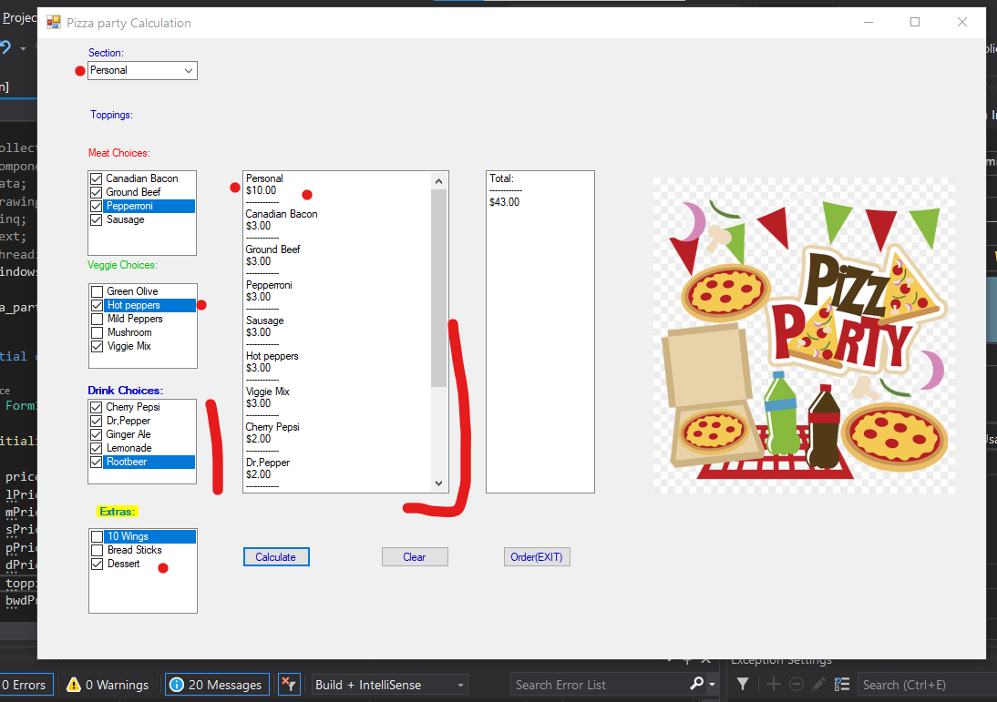

Bottom of the list displaying

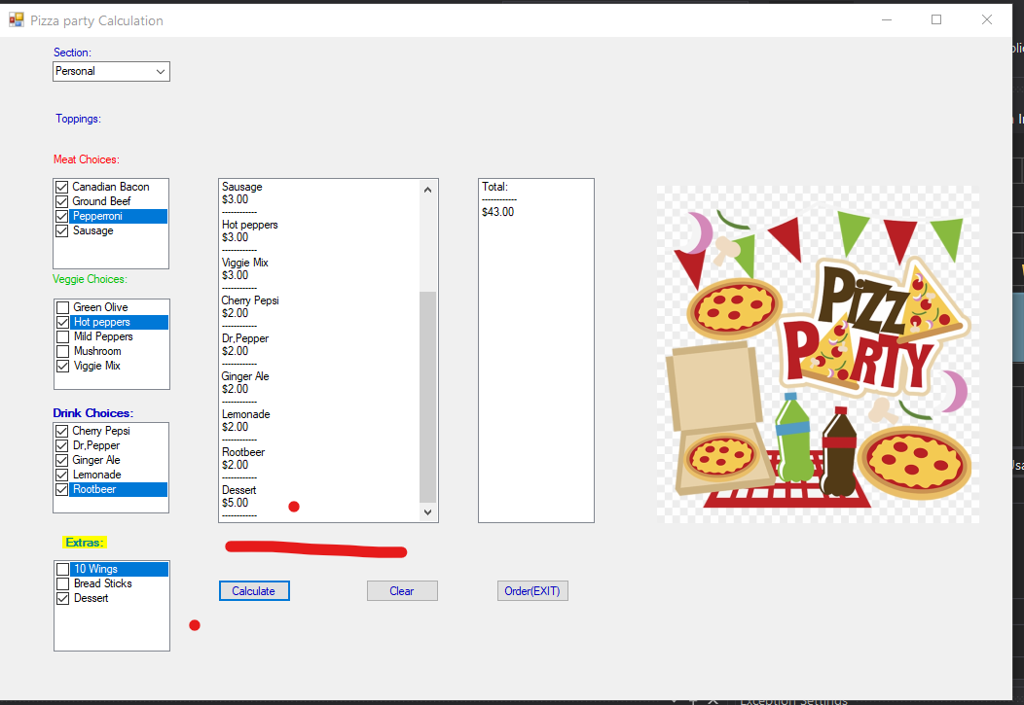

All options selected and listed, totals

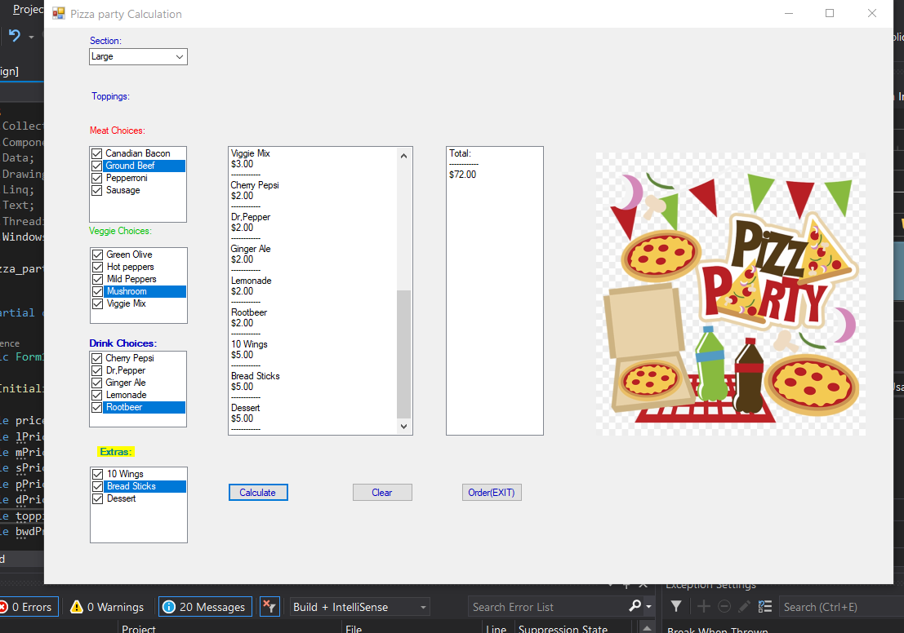

Drink

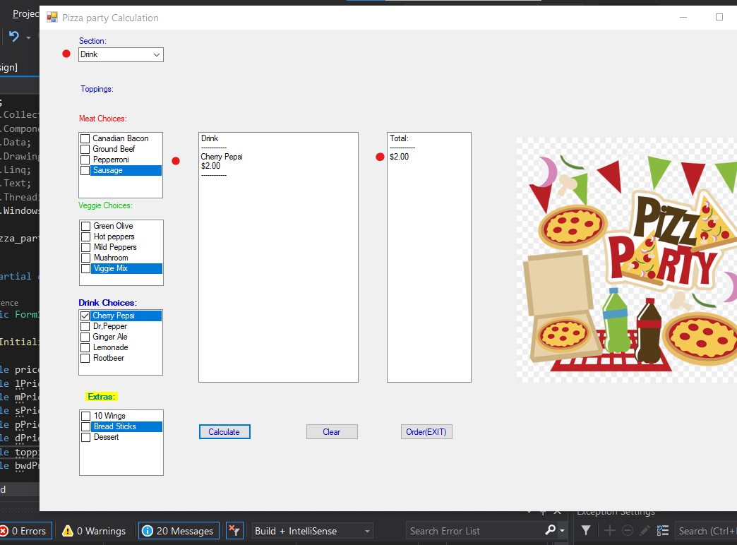

Extras + drink

